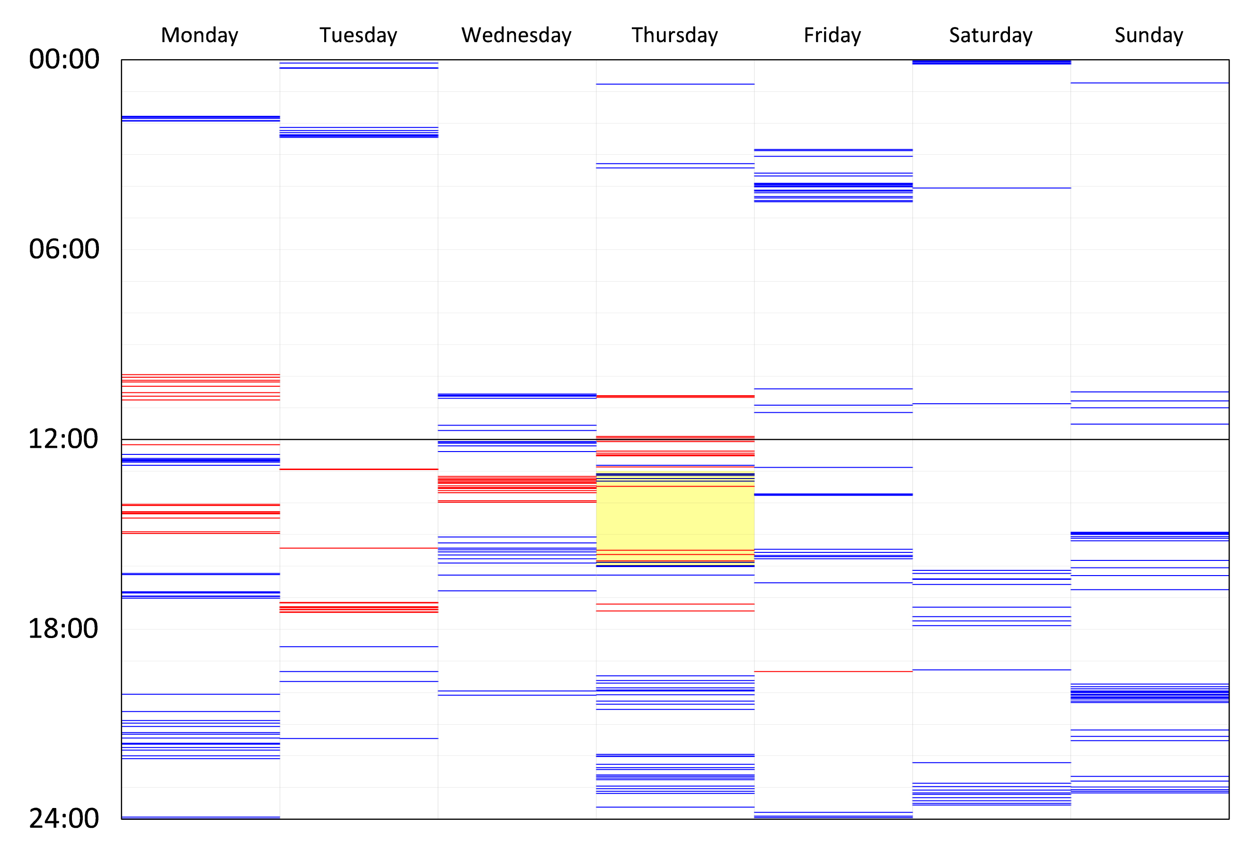

Figure 1 Distribution of comments made throughout the semester over a weekly calendar. Blue lines indicate student comments, red lines indicate tutor comments, and yellow highlight indicates the formal teaching hours

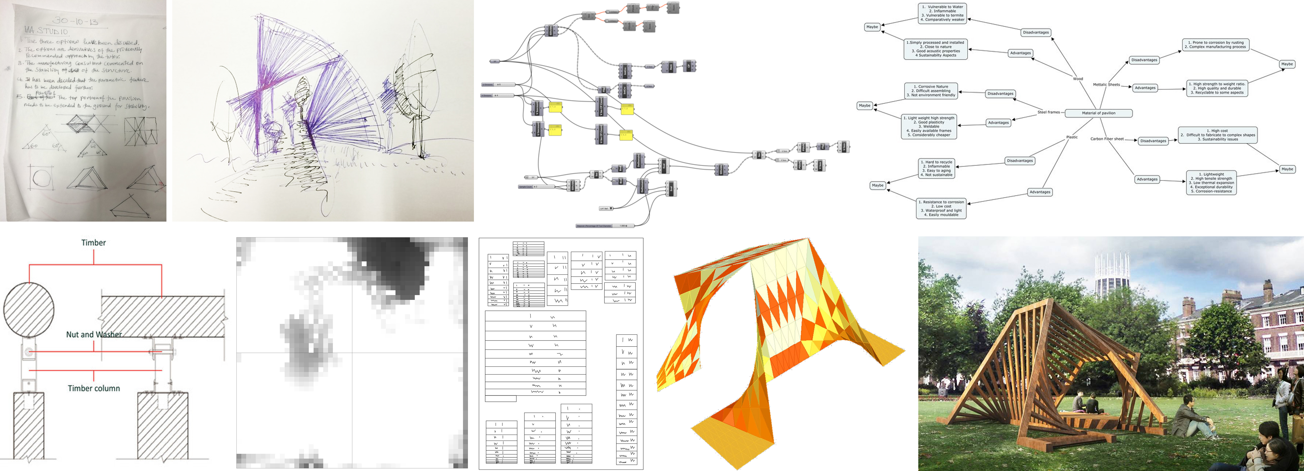

Figure 2: Different representations uploaded to the Wiki sites by students. From left to right and top to bottom: Notes from a group meeting (Group 10), handmade sketches (Group 10), Grasshopper modelling sequence (Group 10), mind-map (Group 5), building detail (Group 9), radiation map (Group 2), laser cutting patterns (Group 7), solar lighting analysis (Group 10) and realistic render (Group 10).

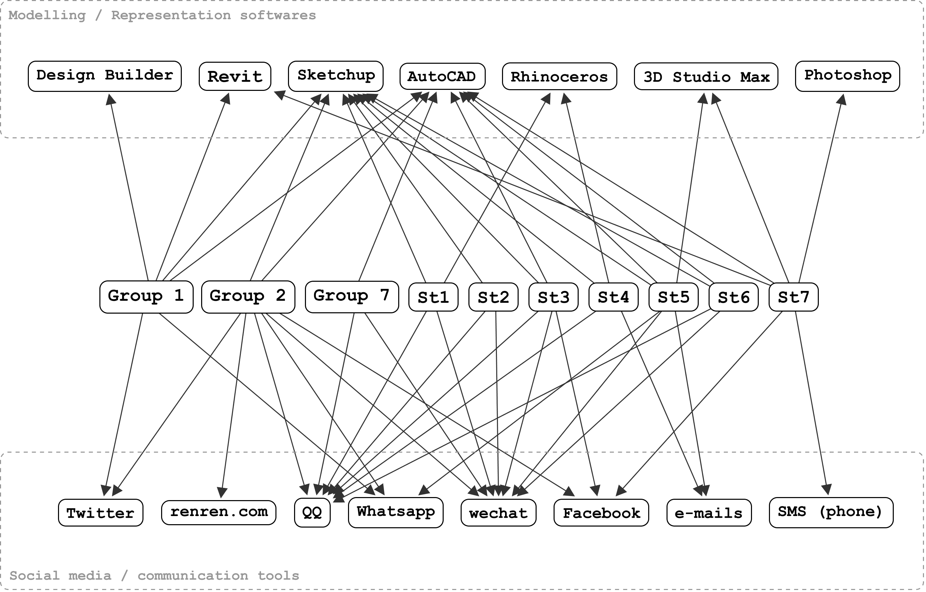
Figure 3 Use of different meditational and instrumental media during the semester

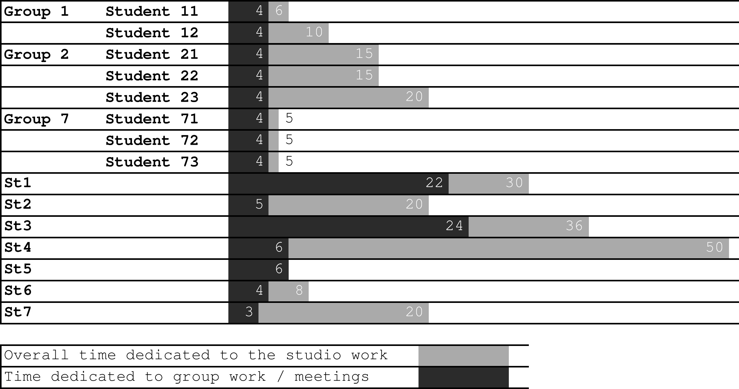
Figure 4 Variances in student's perceptions of their studio related workload

Table 1 Modes of online guidance provided by the tutors
CATEGORY | Posts by Tutors on the Wiki Communication pages
Affective | “… I think your group communication through this Wiki site is one of the best in the class. And [Student] is doing a great job stimulating the group to be more active on the Wiki….”
Corrective | “… could be done as a lofted surface... you may use the script i gave you last week for grasshopper” (referred to the 3D modelling of a design alternative, suggesting to modify the modelling technique).
Informative | “… the Grasshopper model still seems to be trying to copy the Rhino model. The contribution of the "parametric design process" to the evolution of the design is not very clear. The parametric model does not seem to be driving the process. Have you already tried to update your parametric model in respond to the feedback you received at the interim?”
Socratic | “… there is still lack of clarity about how the structure is actually going to work. The issues about ergonomy, and health/safety regarding the walking path in the pavillion are not fully resolved. However, the unique process you've followed from the very beginning is really interesting - the formation of the space and then subtracting it from the overall form to achieve the final form.”

Figure 5 Pedagogical Framework which places individual and collective knowledge Construction at the centre of the learning process

