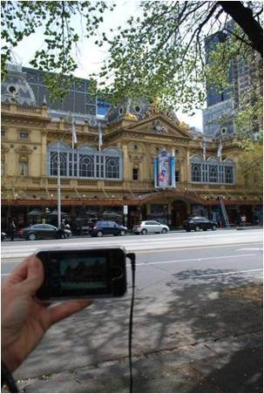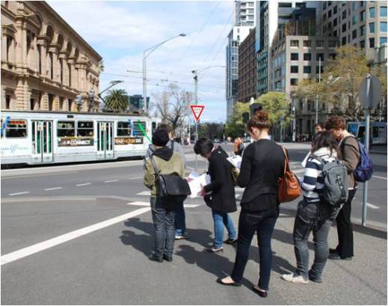

Figure 1. Study 1: Students undertaking Formative walk in Collins Street, Melbourne

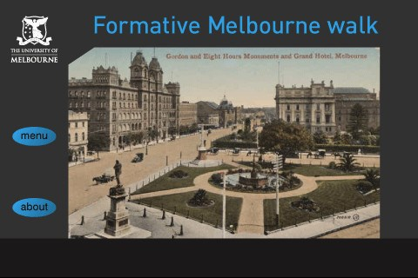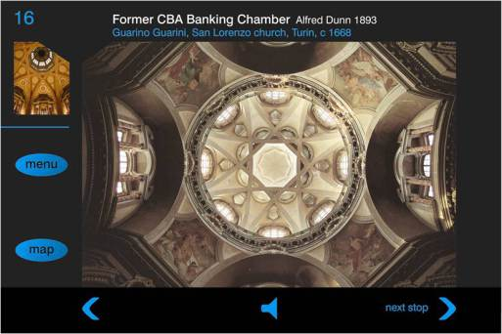

Figure 2. Study 1: Formative Melbourne walk screen shots showing main screen (upper), and view for Stop 16 (lower)

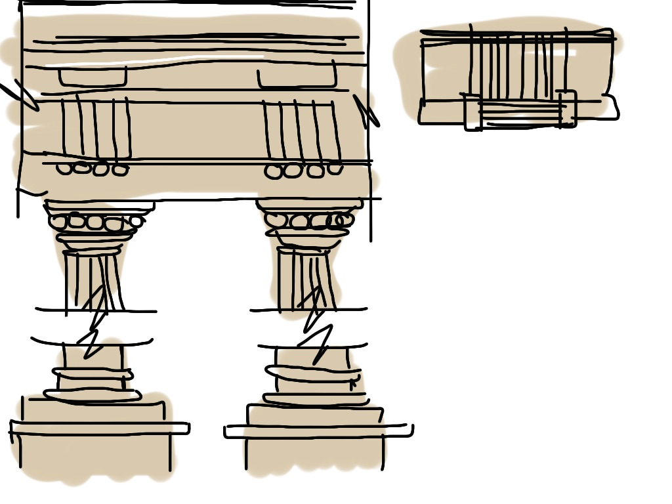
Figure 3. Study 1: Student sketching task carried out on an iPad

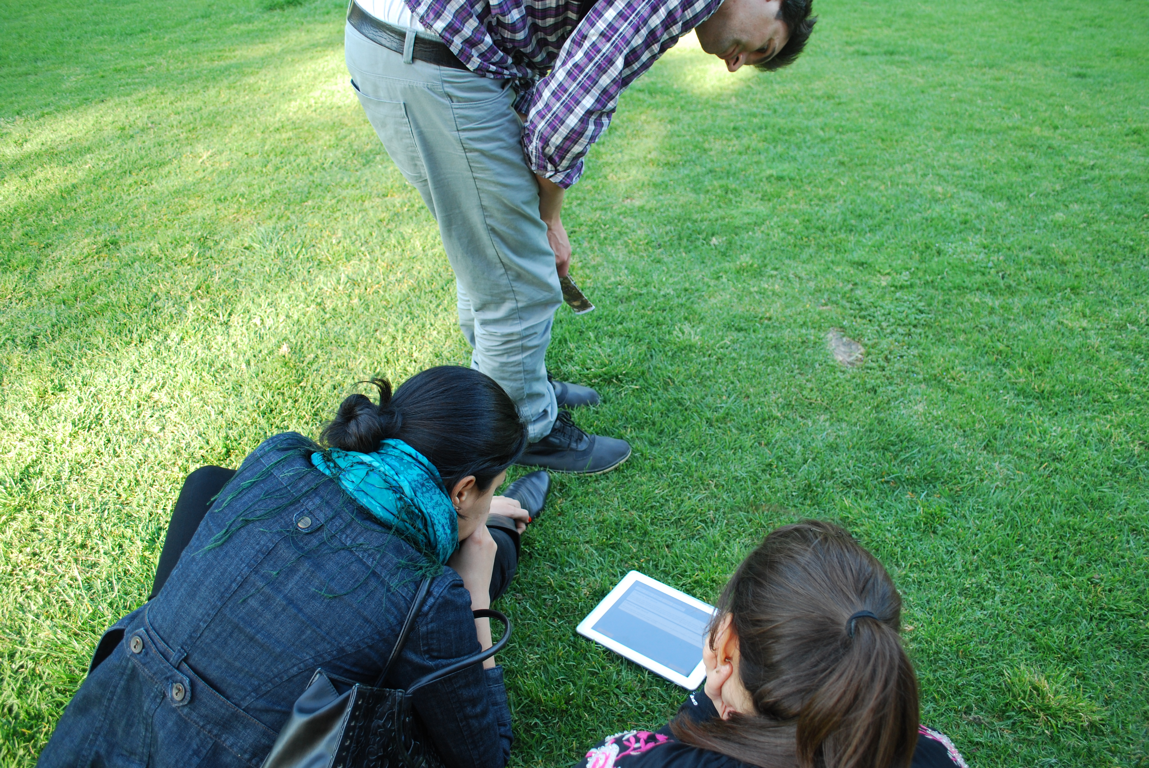

Figure 4. Study 2: students using the Landscape in Time app to view images and listen to audio in the Royal Botanic Gardens, Melbourne.

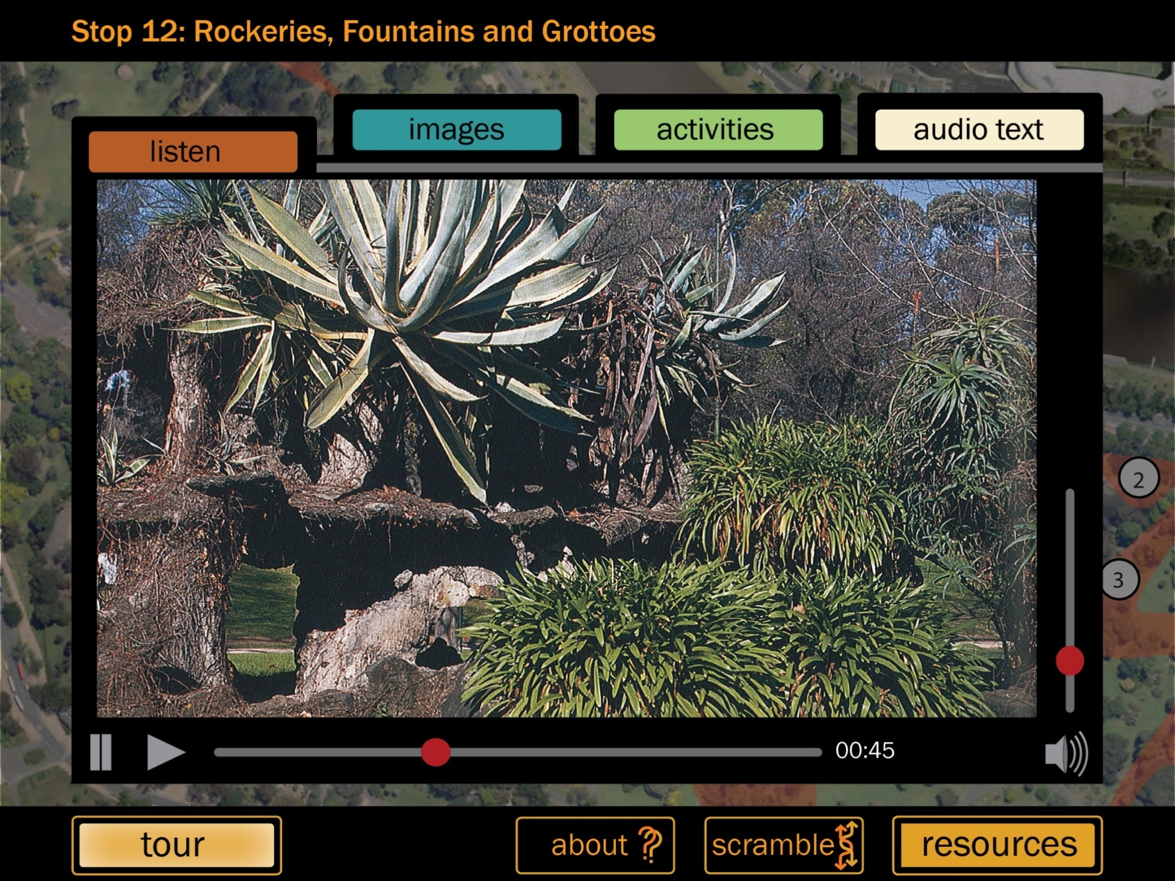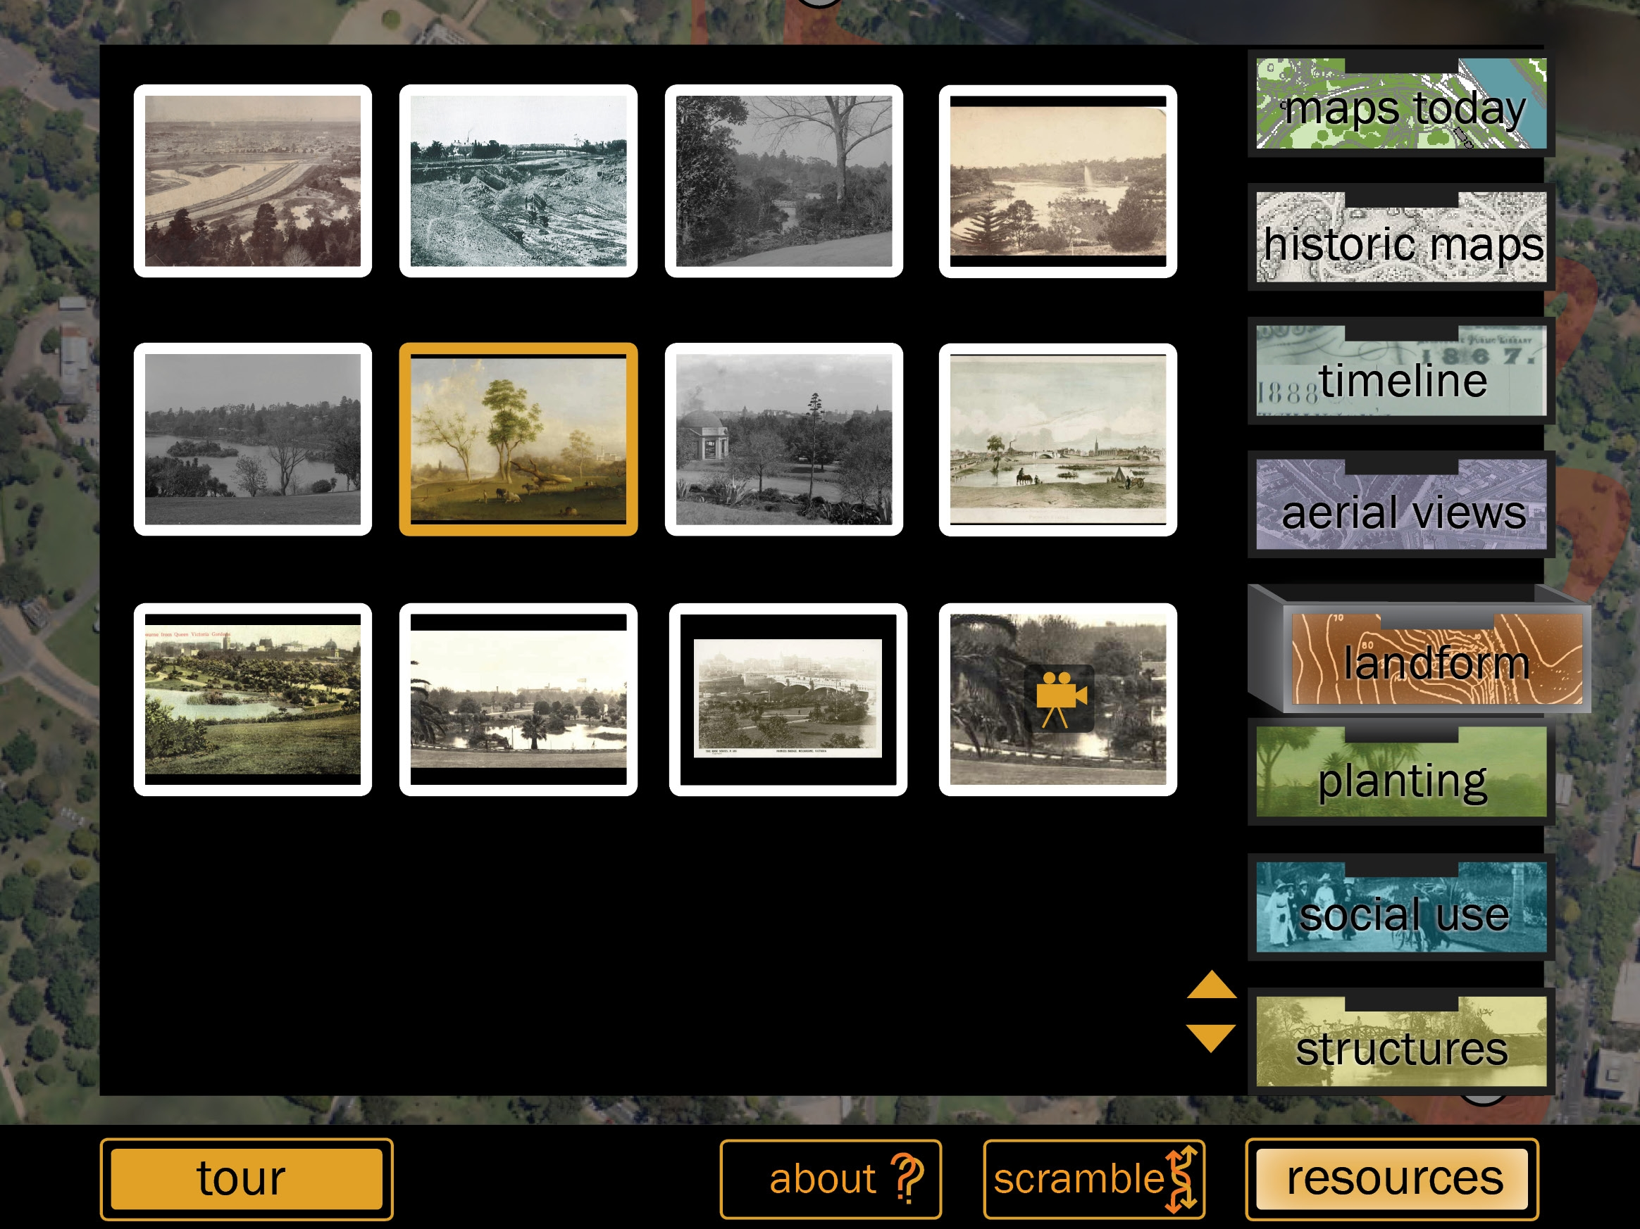

Figure 5. Study 2: Screenshots of the Landscape in Time app, showing main view for Stop 12 with tabs to key resources (upper), and supplementary information provided in archive ‘drawers’

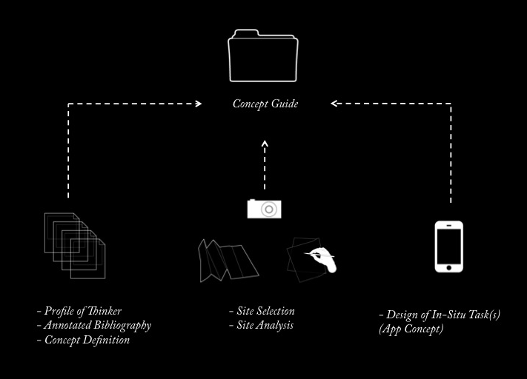

Figure 6. Study 3: Structure of Concept Guide assessment task.

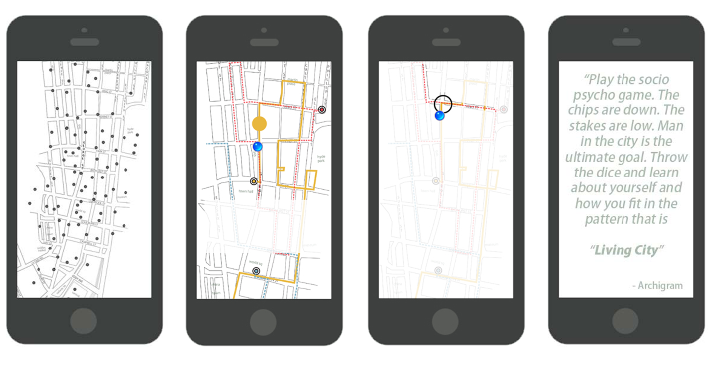

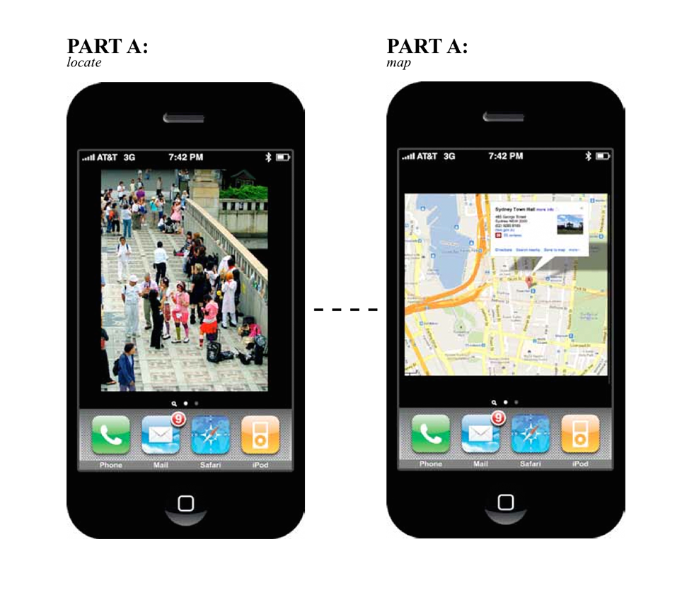
Figure 7. Study 3: Two examples of student work

