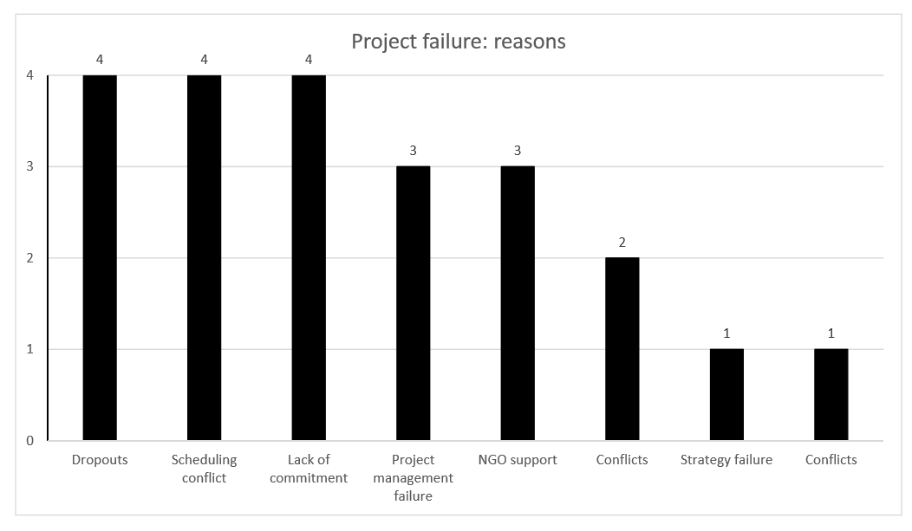
Figure 1. The main reasons stated by the students as responsible for the projects’ failures.
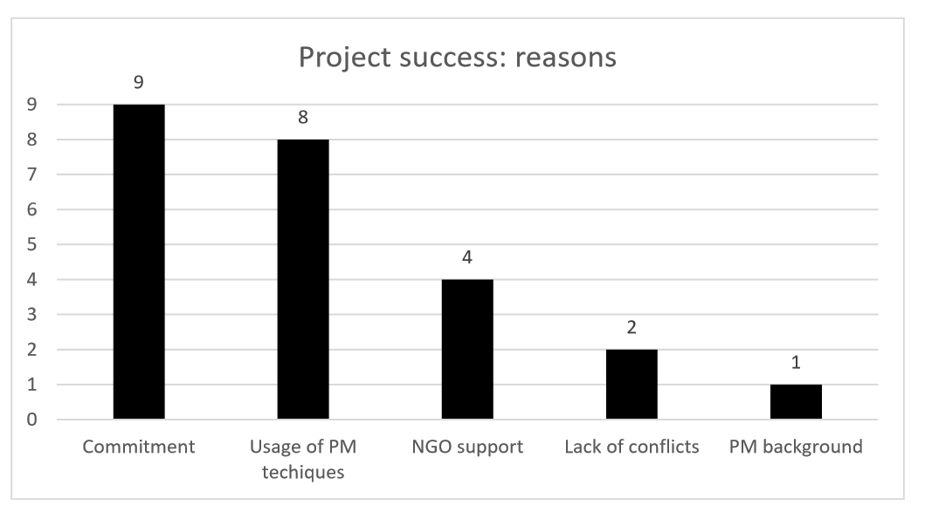
Figure 2. The main reasons stated by the students as responsible for the projects’ success.
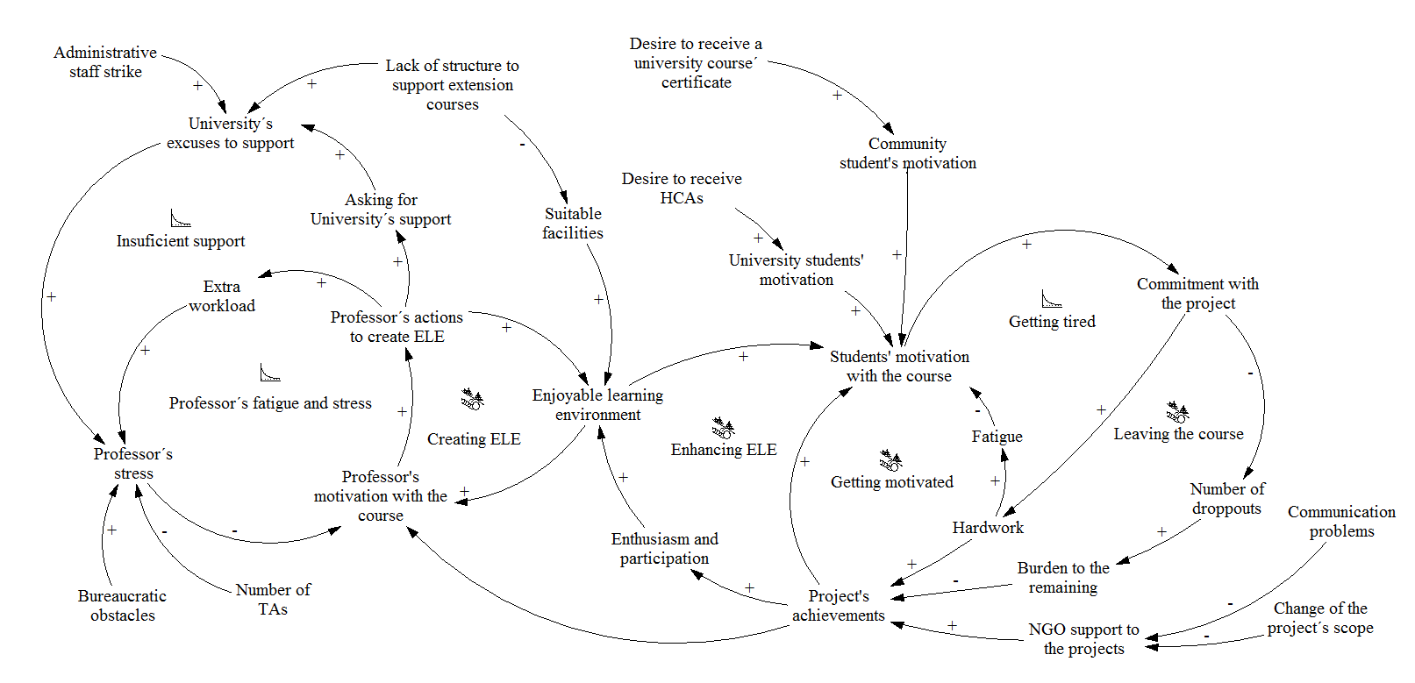
Figure 3. The dynamics present during the development of the course, based on Arantes do Amaral & Gonçalves (2015).

