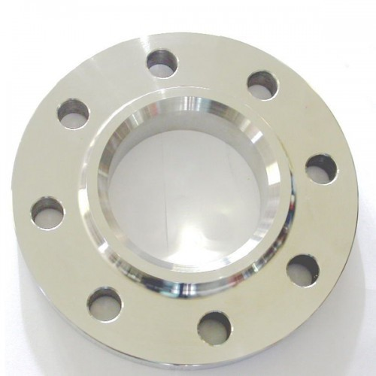
Figure 1: Example of a circular flange for operation under the punch machine

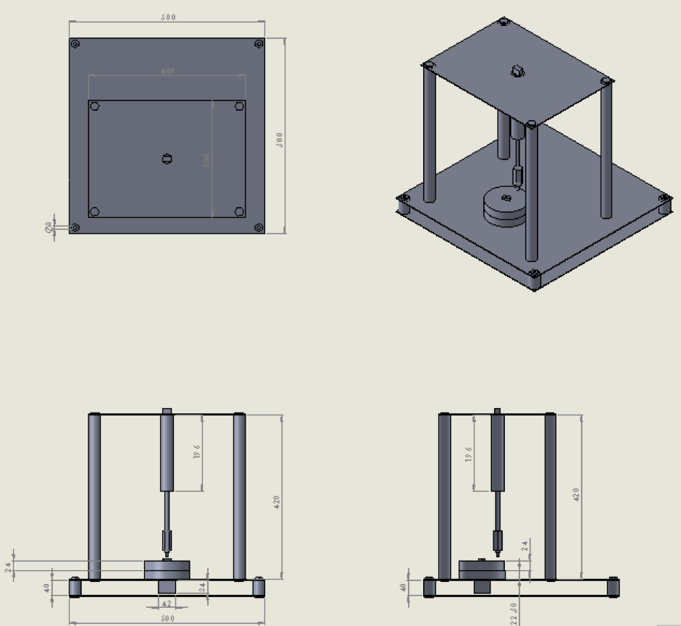
Figure 2: Design of the punching machine, three views drawings of the punch machine
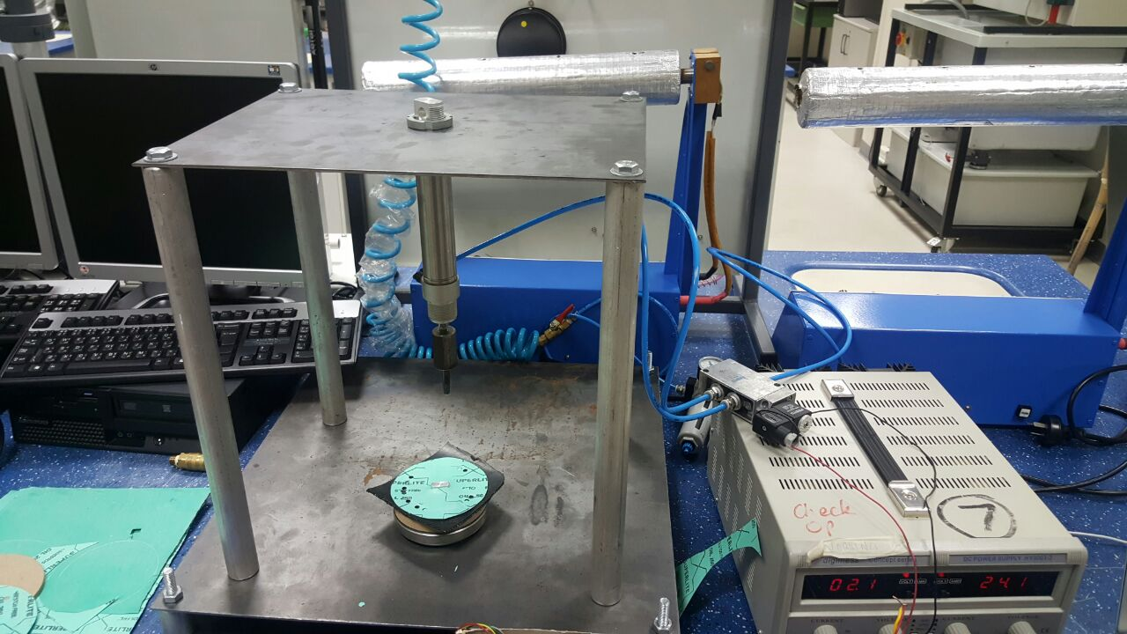
Figure 3: Team 1 punch machine in testing
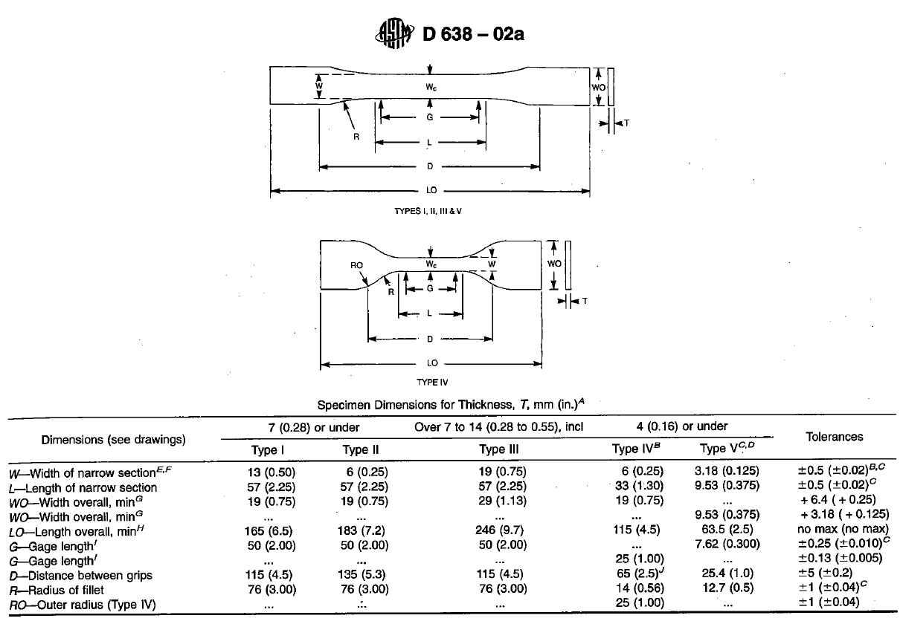
Figure 4: The ASTM D-638-02a standard shape for tensile testing of sheets
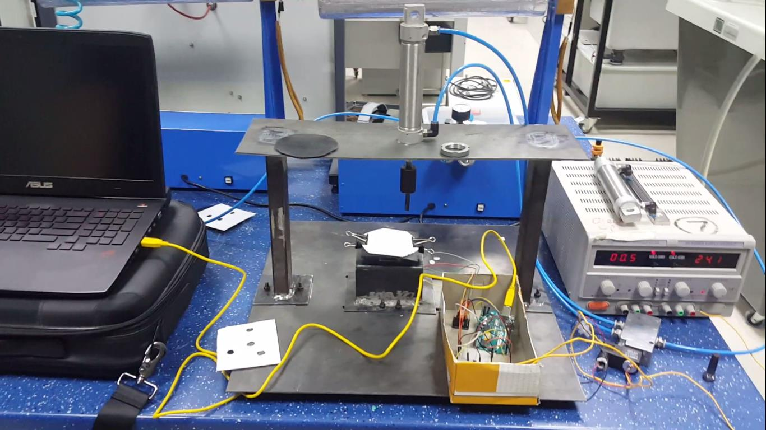
Figure 5: The punch machine of team 2 in testing

